Muhammad Ahmad Raza

467253

#include<iostream>

using namespace std;

int main()

{

TASK 1

cout<<"input the 10 integers:";

int arr[10];

for(int i=0;i<=9;i++){

cin>>arr[i];

}

cout<<"array is:";

for(int i=0;i<=9;i++){

cout<<arr[i]<<" ";

}

}

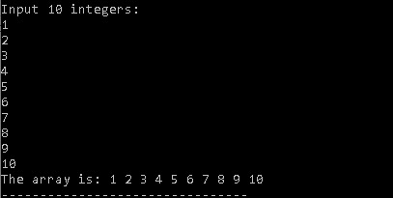

TASK 2

int arr[5];

cout<<"input the 5 integers: \n";

for(int i=0;i<5;i++){

cin>>arr[i];

}

int sum=0;

int product=1;

for(int i=0;i<5;i++){

sum+=arr[i];

product=product\*arr[i];

}

cout<<"sum:"<<sum<<"\t\t"<<"product is:" <<product;

}

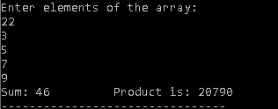

TASK 3

Int n;

Cout << “Enter the size of the diamond : “;

Cin >> n;

Char array[n][n];

For(int i = 0; i < n; i++) {

For(int j = 0; j < n; j++) {

Array[i][j] = ‘ ‘;

}

}

For(int i = 0; i < n/2+1; i++) {

For(int j = n/2-i; j <= n/2+i; j++) {

Array[i][j] = ‘\*’;

}

}

For(int i = n/2+1; i < n; i++) {

For(int j = n/2-(n-i-1); j <= n/2+(n-i-1); j++) {

Array[i][j] = ‘\*’;

}

}

For(int i = 0; i < n; i++) {

For(int j = 0; j < n; j++) {

Cout << array[i][j] << “ “;

}

Cout << endl;

}

}

